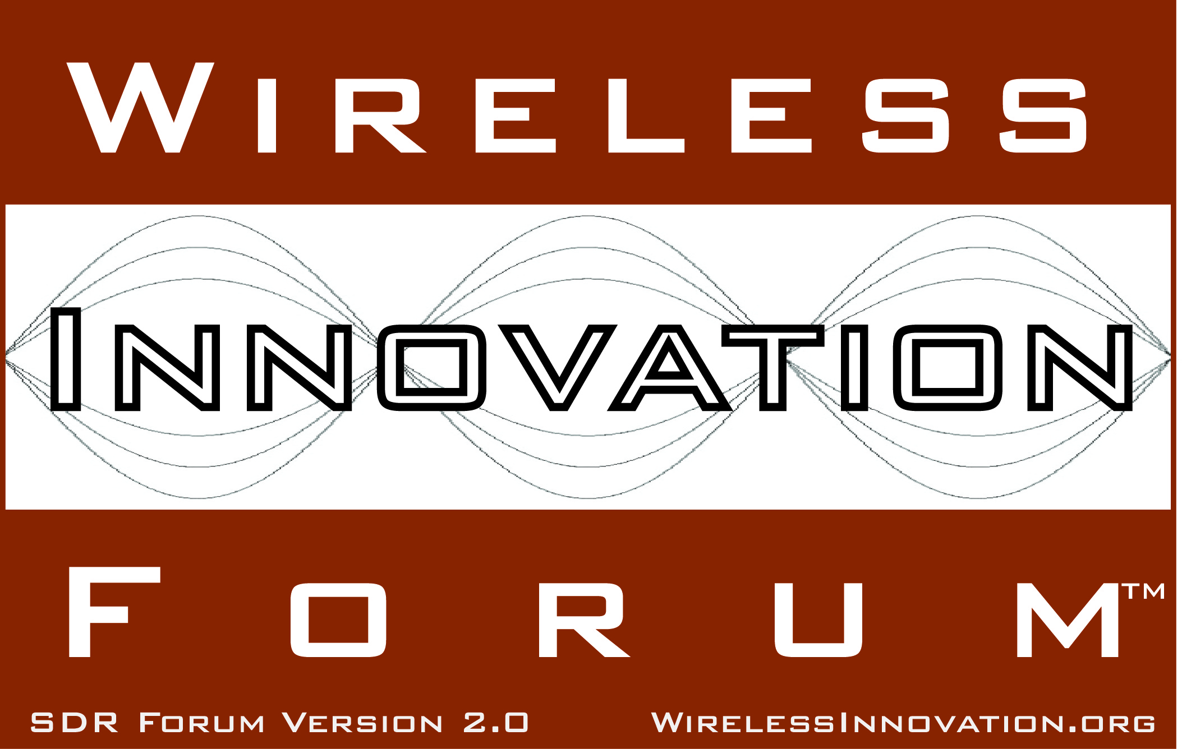

Exceptional Program for SDR-WInnComm-Europe 2013 Announced
Features Tactical Radio Workshop, Daily Keynotes from Industry Leaders and 5G Panel
For Immediate Release
Munich, Germany and Washington, DC - 2 May 2013 – The Wireless Innovation Forum (www.WirelessInnovation.org) announced today the program for the 2013 Wireless Innovation Forum European Conference on Communications Technologies and Software Defined Radio, to be held 11-13 June 2013 in Munich, Germany.

Attracting delegates including investors, commercial network operators, radio manufacturers, system integrators, government procurement officials, regulators, engineering service providers and consultants, SDR-WInnComm-Europe is the only European event devoted to the advancement of wireless radio technologies from research through deployment. The program features three days of keynotes by industry leaders, eight technical sessions, 5G panel, invited presentations, a day-long Tactical Radio Workshop and an ALOE Framework and Waveform Design Tutorial.

“The SDR-WInnComm European Conference consistently delivers strategically relevant programming to the commercial, defense and academic wireless communications systems innovators and this year is no exception” said Conference Chair Kuan Collins of SAIC. Due to the caliber of professionals that attend and present their work, and outstanding keynote speakers, it is a venue where engineers, customers, and executives can communicate with each other about wireless communications system requirements, design, products, use cases and have meaningful impact within their respective domains because of this interaction.”

Keynotes will include:
- Dr. Marc Adrat, Project Manager Software Defined Radio, Fraunhofer FKIE
- Dr. Boyd Buchin, Head of Sales Army Communication Systems Germany, Rohde & Schwarz
- Manfred Fleischmann, President and CEO, Rohde & Schwarz
- Petri Mähönen, Professor, Founding Director of the Institute for Networked Systems, RWTH Aachen University
- Markus Mueck, Chairman, ETSI RRS Technical Committee

Thursday's 5G Panel will be moderated by Gerd Aschied (RWTH Aachen University) and feature panelists Gerhard Wunder (5G Now), Afif Osseiran (METIS Program) and more.

This year's event also boasts eight technical program sessions: Wireless Networks, Civil Communications (EDGE, WiMax, LTE), Spectrum Efficiency, Tactical Radio Communications, Modeling and Simulation, Implementation Issues, Heterogeneous Platforms (FPGA, Multicore), and Spectrum Sensing and Interference Mitigation.

In addition, five invited presentations will be featured:
- Tuesday, 11 June 2013, 10:30
  - "UMIC Research Program", presented by Dr. Gerd Ascheid, RWTH Aachen
  - "High Data Rate Technology for HF communications (HDR-HF)", presented by Mr. Ewald Hedrich, Fraunhofer IIS
  - AMIS Program, Alberto Quintana, Indra
- Thursday, 13 June 2013, 13:30
  - "Acropolis Overview", presented by Dr. James Neel, Cognitive Radio Technologies
  - "CRS-I", presented by Paulo Marques, Instituto de Telecomunicações

Click here to view the draft agenda, complete with links to abstracts of all the papers being presented at SDR-WInnComm-Europe 2013. (Please note that these are draft paper assignments. Final paper and presentation acceptance notifications go out on Friday, 3 May 2013, after which the program will be finalized.)

This fifth annual conference will also feature Tactical Radio Workshop where you can hear the latest tactical radio and SDR programmes update, US JTNC, ESSOR, COALWNW, France, Germany, Italy, Sweden. Learn about the future evolution of international SDR SCA standards, SCA, ESSOR Architecture, and Wireless Innovation Forum. Understand and discover the key technology evolutions that will boost the SDR Platforms performances. Click here to view the schedule and learn more.

To register, click here: http://www.regonline.com/SDR-WInnComm-Europe2013. Registration is discounted if you register prior to 10 May 2013.

Platinum Sponsors include General Dynamics C4 Systems, Harris Corporation, Indra Sistemas, OIS and Selex ES.

Additional information can be found at http://Europe.WirelessInnovation.org.

# # #
About the Wireless Innovation Forum
Established in 1996, The Wireless Innovation Forum (SDR Forum Version 2.0) is a non-profit mutual benefit corporation dedicated to driving technology innovation in commercial, civil, and defense communications worldwide. Members bring a broad base of experience in Software Defined Radio (SDR), Cognitive Radio(CR) and Dynamic Spectrum Access (DSA) technologies in diverse markets and at all levels of the wireless value chain to address emerging wireless communications requirements. To learn more about The Wireless Innovation Forum, its meetings and membership benefits, visit www.WirelessInnovation.org.

Editorial Contacts
Lee Pucker, 604-828-9876, Lee.Pucker@wirelessinnovation.org or
Stephanie Hamill, 970-290-9543 or Stephanie.Hamill@wirelessinnovation.org

